ASEAN-Russia Cooperation Key to Strengthening Food Security

Jakarta, 13 July 2023 - Indonesia is pushing for strengthened cooperation in the field of food security between ASEAN and Russia. This was conveyed by Indonesian Foreign Minister Retno Marsudi during ASEAN Foreign Ministers' Meeting with Russian Foreign Minister Sergey Lavrov in Jakarta (13/7).
Minister Retno stated that Russia has been a dialogue partner of ASEAN for over 26 years. Five years ago, their relationship was elevated to a Strategic Partnership. However, the world's situation has drastically changed at the moment.
"A paradigm of collaboration is needed to save the world. As friends of both Russia and Ukraine, Indonesia is tireless in calling for peace. Our partnership must translate this paradigm into concrete actions," said Minister Retno.
Minister Retno hoped that Russia could support the mainstreaming of the ASEAN Outlook on the Indo-Pacific (AOIP) and ASEAN's work with its partners.
There are two areas of collaboration that need to be advanced.
First, cooperation in the field of food security. ASEAN plans to submit the Leaders' Declaration on Strengthening Food and Nutrition Security to Respond to Crises at the 43rd ASEAN Summit in September.
"Russia's support for this initiative is crucial, considering its status as a global producer of wheat and fertiliser," said Minister Retno.
Second, ensuring a nuclear weapons-free zone in Southeast Asia. ASEAN was established to maintain long-term peace and inclusive prosperity in the region. This cannot be achieved without ensuring Southeast Asia remains a nuclear weapon-free zone.
"Therefore, all nuclear-weapon states must advance non-proliferation and disarmament. For that, I hope Russia can accede to the Southeast Asia Nuclear-Weapon-Free Zone (SEANWFZ) Treaty Protocol as soon as possible," said Minister Retno.
Meanwhile, the Russian Foreign Minister affirmed Russia's support for ASEAN's centrality in building an inclusive regional architecture in the Indo-Pacific as the foundation for security and prosperity based on the principles of the UN Charter.
In the meeting, ASEAN countries pushed for enhanced economic, energy, and food security cooperation through the implementation of the 2021-2025 Plan of Action. They also encouraged cooperation in tourism, science and technology, smart cities, digital economy, and technology transfer.
Regarding security aspects, the meeting discussed the importance of cooperation in combating drug trafficking, terrorism, and cybercrime. ASEAN countries requested Russia's accession to the Southeast Asia Nuclear-Weapon-Free Zone (SEANWFZ) Treaty Protocol.
They also called for peaceful conflict resolution and invited Russia to utilise ASEAN platforms such as the East Asia Summit (EAS) and ASEAN Regional Forum (ARF) to advance peaceful dialogue.
This year marks the 5th anniversary of the ASEAN-Russia Strategic Partnership. The meeting adopted the Joint Statement of ASEAN and Russia Foreign Ministers on the Occasion of the 5th Anniversary of ASEAN-Russia Strategic Partnership, which, among others, agreed on inclusive cooperation within the framework of the ASEAN Outlook on the Indo-Pacific.
***
For further information, please contact the following:
Director for Information and Media of the Ministry of Foreign Affairs - Hartyo Harkomoyo (+62811831899)
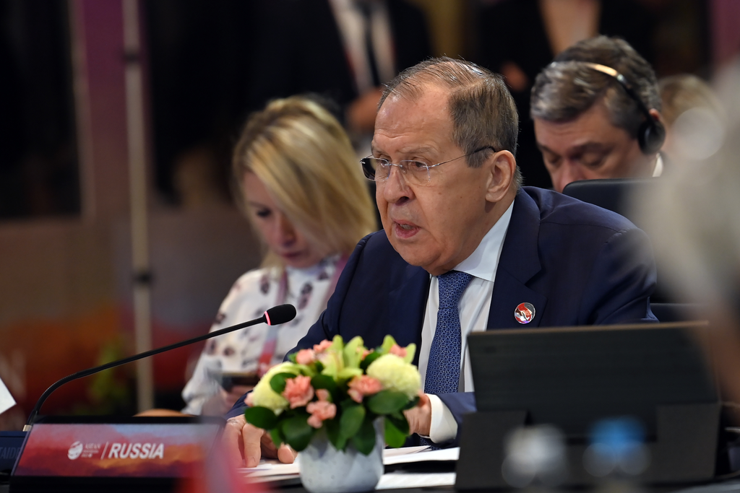

Indonesia is pushing for strengthened cooperation in the field of food security between ASEAN and Russia during ASEAN Foreign Ministers' Meeting with Russian Foreign Minister Sergey Lavrov in Jakarta (13/7) (Photo: Ministry of Foreign Affairs of Indonesia).

